**ARE YOU OVER 75 & LIVING ALONE?**

**WOULD YOU LIKE TO MEET SOME NEW PEOPLE?**

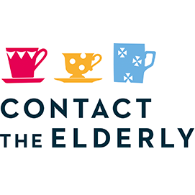 

THEN COME JOIN US!

At Contact the Elderly, we hold free monthly tea parties for small groups of people aged 75 and over, who live alone and need a hand getting out and about. It’s an ideal way to brighten up your Sunday.

Our volunteer drivers will take you to and from the party safely as well as enjoying the tea with you. At the volunteer host’s home you will receive a warm welcome and plenty of tea and sandwiches.

It is a free service. We are setting up multiple groups in

**ST HELENS**. If you are interested in joining a local group please contact the Freephone on 0800 716 543 or contact

Prabina Lord-Doyle 0161 460 2950

Prabina.lord-doyle@contact-the-elderly.org.uk

THANK YOU

**Registered Charity: England and Wales 1146149 Scotland SCO39377 Company No. 07869142**

**Website:** [**www.contact-the-elderly.org.uk**](http://www.contact-the-elderly.org.uk/) **Free phone: 0800 716543**